5.85: Denote the magnitude of the acceleration of the block with mass 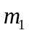as a; the block of mass 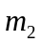 will descend with acceleration 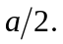 If the tension in the rope is T, the equations of motion are then

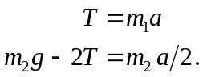

Multiplying the first of these by 2 and adding to eliminate T, and then solving for a gives

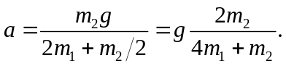

The acceleration of the block of mass is half of this, or 